Your Best as Default Registration
This information is confidential and sacred. You have been personally selected by Anahata to participate in this program and it is not open to the general public so do not share this information with anyone else.
The 6-month Your Best as Default Journey will cover the following information delivered in a combination of On Demand and Live delivery. The goal of the journey: Think it> Do it> Be it in order to manifest your best life. The program is a Fractal in nature, you can zoom in and out to any portion you seek more of by diving into the On-Demand information when you need or desire. The On-Demand journey therefore, is at your own pace and it is ALL optional content (that is highly recommended) but not required in order to achieve the intention of the Course Series. It is recommended to dedicate 15 – 30 minutes per day to this program with the opportunity to expand into much more content (again, as you desire or need). Additionally, we will meet once per week for an hour in the “Thank Tank”.
The program is segmented into six phases.
Phase One: Grid4Gaia Masterclass Series* (click the link for content) and Onboarding (Explaining the program, timeline, meet each other). The Onboarding will be a 2-hour meet and greet with a tour of the member center.
Phase Two: Remap with Codes* (click the link for content) and Gearing Up and Foundation (Science of Flow State, Motivation, and Biochemistry, Hermetic Principles).
Phase Three: Remap with Codes* (click the link for content) and Mess into Medicine Journal (Where Pain meets Purpose and Equals Passion).
Phase Four: Vishuddha Coursework* (see below notes) and Unleashing Your Passion and Plan (Goal Setting, Mindsetting & Accountability).
Phase Five: Vishuddha Coursework* and Alignment as Default and Overcoming Obstacles (Your Best as Default).
Phase Six: Vishuddha Coursework* and Be it to See it and Momentum Past Fear (Giving Up is Not an Option).
PURPLE: These will be delivered in Daily Framers (5-minute daily audios).
Note: This program is non-linear. You will Think, Do and Be continually and add more and more layers of knowing and that knowing will become action and those actions will become new habits and defaults. It is, therefore, extremely difficult to explain this in a linear phase by phase outline. Please keep that in mind if you are confused with the flow.
Facebook Group
A Facebook group will be an ongoing place to post responses, questions, and interact with other Tribe Members.
*All asterisked items are considered a bonus beyond the program to ensure your success.

5-Minute Framers (Now Moments)
The “Now Moment” Framers will be short and sweet audios which deliver content to support deep integration on a Mental level, into Doing (action) and into Being (as default). We will learn (mental), do (and attract capabilities), and experience the realities we desire as delivered in layers by these 5-minute digestible framers which compound over time and strengthen the mechanism and allowance for true and lasting change into alignment with the future you desire. Think > Be > Do. We will be working with the 7 Hermetic Principles in conjunction with the mapping below and the outline above.
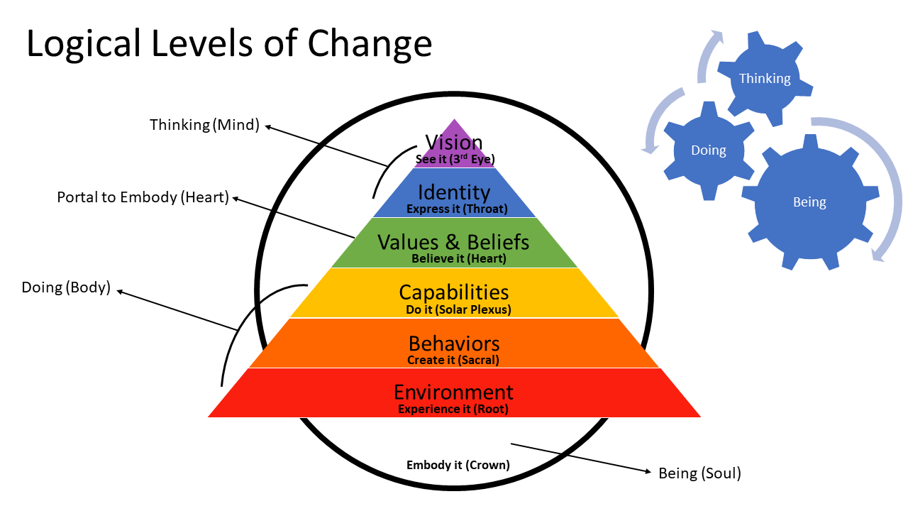

Weekly Thank Tank
We will come together once per week for an hour to share and celebrate. To flex our muscles (knowing), integrate our lessons (doing), share our goals and desires, and celebrate our wins and losses (what’s being) in order to share support for each other as well as Master our choices are real-world happenings. Gratitude will become the way you frame everything (even your challenges) which is a HUGE part of Being it to See it!

Optional Vishuddha Mastery Coursework Overlay
The following high-level topics and subcategories are available as a supplement to your journey as desired. Each topic includes On Demand training, guides & processes, a replay of group coaching and small group masterminds from another Course Series I hosted called Vishuddha Mastery. Keep in mind that as you “learn” these things, you can fold them into your own programs and use them as part of your own Medicine to service your own niche in your own unique way so you are learning and able to use the information for your own offerings (how you set up your programs). Additionally, various elements and the resources within will be referred to during any 5-minute Framer which mentions anything we dive deeper into here. That way, you don’t have to figure out what’s available… it will be referenced as a “need to know more?” option.
Cycle One: Shadow Integration & Block Removal (release and rewire old programs of fear and limitation to reset your Point of Magnetism to your Source Point of Magnetism – aligned with your highest path and expansive self). The Remap with Codes Journey is a longer and more in-depth version of this but touches all areas of your life vs. just related to business as this one does.
- release the lies and limiting behavior we’ve been used to surrounding money, marketing, worth, expansion and magnificence
- Out of scarcity and lack magnetism and into a set point of abundance and prosperity magnetism
- The mental and emotional blocks you’ve previously experienced will atrophy away as we rewire your responses and align with unconditional love, abundance, joy, and ease
- You’ll learn tips and techniques to transform your fears into confidence
- An integral part of any transformative program you end up developing yourself (your programs!)
Cycle Two: Discover and Distill your Vishuddha Medicine (gifts) & Ideal Clients
- Discover and clarify who your ideal clients are by understanding what your gifts are, what’s in demand, and who will pay for them
- Learn to view your “mess” as potential super powers!
- What’s your Vishuddha Medicine (your “especially pure” medicine and who is it for?)
- How does Anahata Codes weave into your offering? Not a requirement! But a juicy option as I empower my students to use this Technology as part of their gifts!
- When we focus in on our Niche and cut through the “clutter” of being too broad. Our Especially Pure Medicine is distilled down and clarified into the essence which will most serve the people who are your ideal clients. In its pure form, it is clear what you do and who it’s for. People can feel it and are drawn to you through this clarity and focus.
- This will shift and expand overtime as you do. The grid from which to view it will remain applicable.

Cycle Three: Use the Law of Attraction of Energy Medicine to Rise Above the Competition (infuse in your business, body, and for your clients/services)
- How to find and infuse the perfect Assisting Frequencies for your product, service, sessions, offerings, book (depending upon your business focus)
- For your business materials and offering, for your own energy matrix and for your actual clients as part of what sets your program or offering apart
- Certification is included in this special On Demand offer
Cycle Four: Design Your Vishuddha Offering & Pricing (Your online or in-person group program, individual program, service, product, or book)
- This is where we lay out a plan based on your gifts, your ideal clients, and where you wish to interact with them (in-person or digitally or both, or in a product)
- We’ll consider your pricing as we deconstruct backwards to be sure we reach your financial goals
- We’ll work through how to structure your Vishuddha Talk (the free workshop or session from which you’ll fill your paid programs or book your ideal clients into your packages)
- I’ll help you outline your paid offerings, the workshops, programs, book, or products you offer
Cycle Five: Master Enrollment Using the D.O.V.E. Process & Create a Plan to Fill Your Program, Service or to sell your Product
- I’ll coach you on how to present yourself during your Vishuddha Talk (the free workshop or talk from which you fill your paid programs)
- You’ll learn how to book “Discovery Sessions” like the one you had with me which lead you to this course
- You’ll learn how to use the D.O.V.E. process to enroll clients
- And we’ll finalize your plan to fill your programs, launch your services, or sell your products, book, etc.
Cycle Six: Mastering Event and Marketplace Logistics (Understanding the best online and in-person platforms to reach the most Ideal Clients where they already are)
- This is the “techy” month where we dive into the logistics of how to get things done (hint: it’s not a website!)
- I’ll discuss the pros and cons of online vs. in-person offerings and what to expect
- I’ll provide in-depth knowledge and best practices on how to most effectively reach your financial goals through your platform of choice (and what those platforms are)
- How to publish a book or launch a product

Bonus:
- The Remap with Codes Journey (worth $499) will be given LIVE over a 9-week period and can be listened to in replay if you aren’t able to dedicate energy to that segment of the journey.

Your Best as Default Pricing
6-month emersion courses similar to this one are going for $10,000+. This is to be expected since you are paying for guidance on a transformation which is going to change your life forever. Given the clarity and assistance you receive, you can make up your investment in just a few months after completing this program, or as you go (depending upon your willingness to for it!). The amount of money you can spend in trial and error of having to figure this out on your own is worth the investment just in time-savings.
As of now, my rates are much lower than most business coaches out there and I am offering something that none of them do; access and permission to build a business around the Anahata Codes and in-depth training to co-create using Magnetism and the Law of Attraction.
It’s more than a business how-to, it’s the business itself, and the grit and determination plus inspiration to get there! Think > Do > Be!
OPTION 1 (Payment Plan)
$150 per month for 6 months
Total Cost: $900
OPTION 2 (Paid in full)
$750
Total Cost: $750
PLEASE REGISTER BY OCTOBER 31st or I can’t guarantee that there will be room for you in the program.

Best as Default On-Demand Registration Form
Choose One:
_________ OPTION 1: 6 months of $150 (REGISTER USING THIS LINK)
_________ OPTION 2: Paid in full $750 (REGISTER USING THIS LINK)
Name:
Billing Address:
City: State: Zip:
Your PayPal email address:
Primary phone:
Primary Credit Card ONLY if you do not have a PayPal Account
(or check made to Holly Hallowell)
Card #
Exp. Date: CVV:
Secondary Credit/Debit Card (if you’d like to split your payment onto 2 cards)
Card #
Exp. Date: CVV:
I hereby commit my BEing into the Best as Default Goddess Program. I understand and agree to the payment plan which I have selected above. I realize I have 3 days from signing to receive a full refund after which I will be fully responsible for the entire financial commitment regardless of my participation in the program. I understand that a Sacred Space has been set for me and that preparation for my admittance has been made. I AM fully in and ready for this transformation.
Signature: __________________________________________ Date: ____________________________
Checks Payable to: Holly Hallowell
(First Payment must be postmarked by October 31st if paying by Check)
Mail to: Holly Hallowell, 76 Winson Ave. Englewood, FL 34223
Digital Copy to hollyhallowell@live.com

